AKS Authentication: Service Principal, Pod‑Managed Identity, and Microsoft Entra Workload ID (Quick Guide)
This short, practical guide explains the three common authentication models used by applications on Azure Kubernetes Service (AKS), and how to implement the recommended Microsoft Entra Workload ID. It includes minimal YAML, the exact Azure CLI commands you need, and context screenshots inserted where they matter.
0) Node/Agent Managed Identity (kubelet UAMI) — Simple, coarse-grained
Coarse-grained, node-level identity — All pods on a node pool share the same kubelet UAMI via IMDS (169.254.169.254). Simple for infra/DaemonSets, but not least-privilege. Prefer Workload Identity for per-pod access.

Quick Start: Grant Permissions
# Assign role to kubelet identity (e.g., Storage access)
az role assignment create \
--assignee <KUBELET_CLIENT_ID> \
--role "Storage Blob Data Contributor" \
--scope /subscriptions/<SUB_ID>/resourceGroups/<RG>/providers/Microsoft.Storage/storageAccounts/<STORAGE_ACCOUNT>Pods that call the IMDS endpoint (169.254.169.254) will now receive tokens for this kubelet UAMI.
⚠️ All pods in that node pool inherit the same identity and permissions.
A) Migrate SP-based Cluster to Managed Identity
az aks update -g <RG> -n <CLUSTER> --enable-managed-identity
B) Separate Control Plane & Kubelet Identities (Recommended)
Create UAMIs
# Control plane + kubelet identities
az identity create -g <RG> -n <CLUSTER>-cp-mi
az identity create -g <RG> -n <CLUSTER>-kubelet-mi

CP_MI_ID=$(az identity show -g <RG> -n <CLUSTER>-cp-mi --query id -o tsv)
KUBE_MI_ID=$(az identity show -g <RG> -n <CLUSTER>-kubelet-mi --query id -o tsv)
B) Separate Control Plane & Kubelet Identities (Recommended)
Create UAMIs
# Control plane + kubelet identities
az identity create -g <RG> -n <CLUSTER>-cp-mi
az identity create -g <RG> -n <CLUSTER>-kubelet-mi

CP_MI_ID=$(az identity show -g <RG> -n <CLUSTER>-cp-mi --query id -o tsv)
KUBE_MI_ID=$(az identity show -g <RG> -n <CLUSTER>-kubelet-mi --query id -o tsv)

New Cluster
az aks create -g <RG> -n <CLUSTER> \
--enable-managed-identity \
--assign-identity $CP_MI_ID \
--assign-kubelet-identity $KUBE_MI_ID \
--node-count 3
Existing Cluster:
az aks update -g <RG> -n <CLUSTER> --assign-identity $CP_MI_ID
az aks update -g <RG> -n <CLUSTER> --assign-kubelet-identity $KUBE_MI_ID

C) Per-Node-Pool Identity (Optional)
New Pool
POOL_MI_ID=$(az identity create -g <RG> -n <CLUSTER>-poolA-mi --query id -o tsv) az aks nodepool add -g <RG> --cluster-name <CLUSTER> -n poolA \ --assign-identity $POOL_MI_ID --node-count 3

Update Existing Pool
az aks nodepool update -g <RG> --cluster-name <CLUSTER> -n poolA \
--assign-identity $POOL_MI_ID
Key Takeaway: Kubelet UAMI is node-wide; for app-level isolation, use Workload Identity instead.

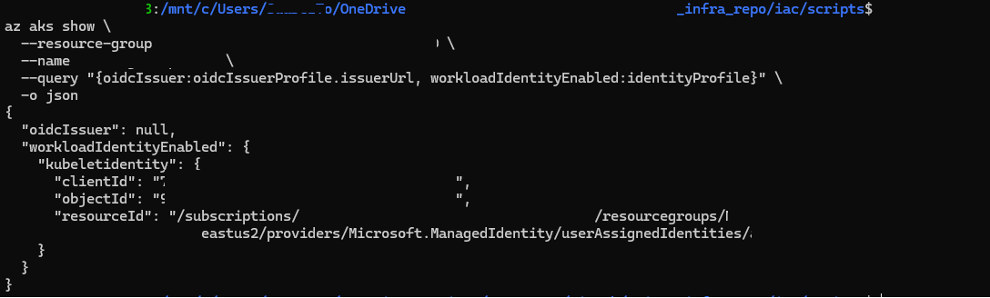

1) Service Principal (client secret/cert) — Classic
Apps authenticate using a Microsoft Entra app registration (service principal) AND a client secret or certificate. You typically store the secret in Kubernetes (or Key Vault) and configure the SDK with it. This model works but requires secret management and rotation.

2) AKS Pod‑Managed Identity (aad‑pod‑identity) — Deprecated

Official Deprecation/Recommendation Notice (paste-as-is)

2) AKS Pod-Managed Identity (aad-pod-identity) — Deprecated

Official Deprecation/Recommendation Notice (paste-as-is)
Right on the official Microsoft Learn resource for Pod-Managed Identity, Microsoft includes the following deprecation notice:
We recommend you review Microsoft Entra Workload ID. This authentication method replaces pod-managed identity (preview), which integrates with the Kubernetes native capabilities to federate with any external identity providers on behalf of the application.
The open source Microsoft Entra pod-managed identity (preview) in Azure Kubernetes Service was deprecated on 10/24/2022, and the project archived in Sept. 2023. For more information, see the deprecation notice. The AKS Pod Identity Managed add-on will be patched and supported through Sept 2025 to allow time for customers to move over to Microsoft Entra Workload ID
Because this feature is deprecated and being replaced by Microsoft Entra Workload Identity, we won’t dedicate much time to it here.
In short, Pod-Managed Identity (aad-pod-identity) allowed individual pods to assume Azure Managed Identities by using custom Kubernetes resources (AzureIdentity and AzureIdentityBinding). A separate controller intercepted pod requests to the Azure Instance Metadata Service (IMDS) and injected the correct identity token.
While it was an important step toward per-pod identity, it depended on custom CRDs and webhook controllers, creating operational overhead and complexity. The new Workload Identity model replaces all of this with a Kubernetes-native OIDC federation, providing simpler, built-in authentication without secrets or add-ons.

3) Microsoft Entra Workload ID — Recommended
Pods use Kubernetes service accounts + OIDC federation to obtain Azure tokens without secrets. This is the modern, supported approach.
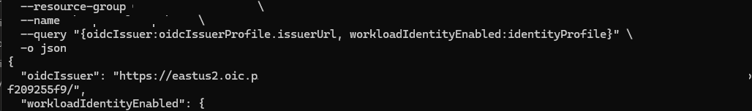
AKS cluster with OIDC issuer enabled (Workload Identity ready).

Prerequisites & Login (do first)
az login
az extension add --name aks-preview -y
az provider register --namespace Microsoft.ContainerService
az account set --subscription <SUBSCRIPTION_ID>
az aks get-credentials --resource-group <RG> --name <CLUSTER> --overwrite-existing

Enable Workload Identity on an existing cluster
az aks update --resource-group <RG> --name <CLUSTER> --enable-oidc-issuer
az aks update --resource-group <RG> --name <CLUSTER> --enable-workload-identity
# Verify
az aks show --resource-group <RG> --name <CLUSTER> --query "{oidcIssuer:oidcIssuerProfile.issuerUrl, workloadIdentityEnabled:identityProfile}" -o json

Register an application for your workload
Create a minimal app registration (no redirect URI needed). This represents your workload identity in Microsoft Entra ID.
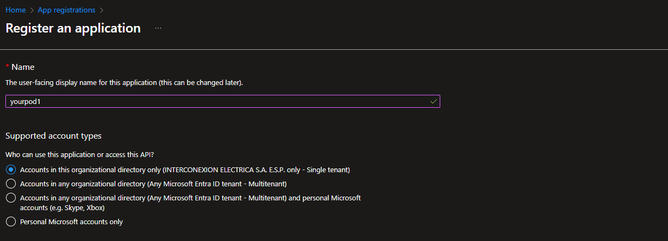
Create a single‑tenant app registration for the workload.

Add a federated credential (link AKS OIDC to the app)
Add a Federated credential under Certificates & secrets → Federated credentials. Choose the Kubernetes scenario or Other issuer, then use your cluster OIDC issuer and the ServiceAccount subject.
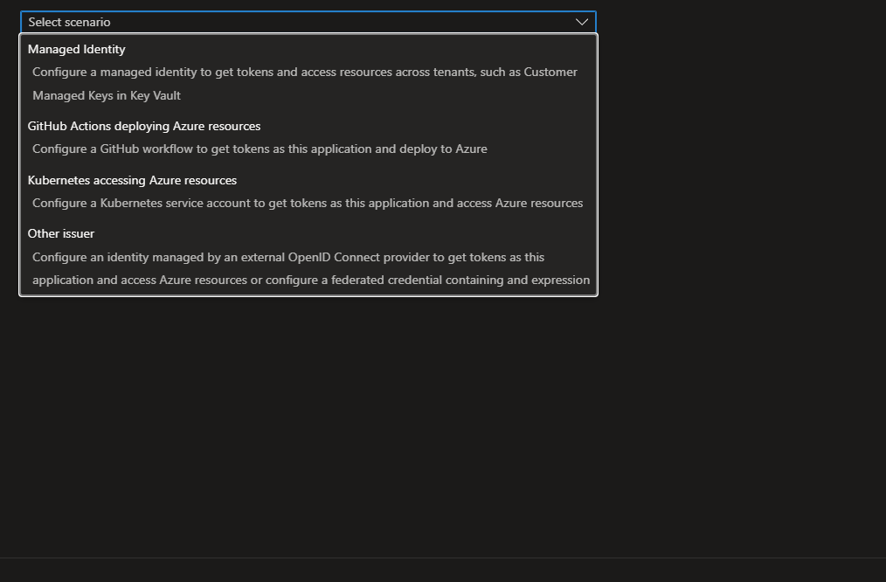
Select the Kubernetes or Other issuer scenario when creating the federated credential.
# Get AKS OIDC issuer
ISSUER=$(az aks show -g <RG> -n <CLUSTER> --query "oidcIssuerProfile.issuerUrl" -o tsv)
# Create an app (or use an existing one)
az ad app create --display-name <WORKLOAD_APP_NAME>
CLIENT_ID=$(az ad app list --display-name <WORKLOAD_APP_NAME> --query "[0].appId" -o tsv)
# Create federated credential for SA subject: system:serviceaccount:<ns>:<sa_name>
az ad app federated-credential create --id $CLIENT_ID --issuer $ISSUER --subject "system:serviceaccount:<NAMESPACE>:<SERVICE_ACCOUNT_NAME>" --audiences "api://AzureADTokenExchange" --name <FED_CRED_NAME>

Kubernetes YAML for Workload Identity
Annotate the ServiceAccount with the app’s client ID, then label the pod template and reference the ServiceAccount.
ServiceAccount:
apiVersion: v1
kind: ServiceAccount
metadata:
name: myapp-sa
namespace: myapp-namespace
annotations:
azure.workload.identity/client-id: "<AZURE_CLIENT_ID>"
# Optional if different tenant:
# azure.workload.identity/tenant-id: "<AZURE_TENANT_ID>"
Deployment (excerpt):
apiVersion: apps/v1
kind: Deployment
metadata:
name: myapp
namespace: myapp-namespace
spec:
replicas: 1
selector:
matchLabels:
app: myapp
template:
metadata:
labels:
app: myapp
azure.workload.identity/use: "true"
spec:
serviceAccountName: myapp-sa
containers:
- name: myapp
image: myregistry.azurecr.io/myapp:latest

Grant the workload access to Azure resources (example RBAC)
# Example: give the workload access to Key Vault secrets
az role assignment create --assignee <AZURE_CLIENT_ID> --role "Key Vault Secrets User" --scope /subscriptions/<SUB_ID>/resourceGroups/<RG>/providers/Microsoft.KeyVault/vaults/<KEYVAULT_NAME>

Validate which identity model is active
# Workload Identity present?
az aks show -g <RG> -n <CLUSTER> --query "oidcIssuerProfile.issuerUrl" -o tsv
# AAD Pod Identity (deprecated) resources still present?
kubectl get azureidentity --all-namespaces
kubectl get azureidentitybinding --all-namespaces
# Output cluster version/state
az aks show -g <RG> -n <CLUSTER> --query "{version:kubernetesVersion, state:provisioningState}" -o json

Notes
- Kubelet identity (user-assigned MI on the node pool) is separate from Workload Identity and remains for node-level operations.
- If both Pod‑Managed Identity and Workload ID are present, migrate apps to Workload ID and remove Pod Identity resources when done.
- Use DefaultAzureCredential or WorkloadIdentityCredential in your app code; no client secret is required.

